# Assignment #5

**Please submit one Word or PDF file for the entire assignment**

|  |  |  |  |  |  |
| --- | --- | --- | --- | --- | --- |
| **Problem I** | **Problem II** | **Problem III** | | | **Total**  **points** |
| **3.1** | **3.2** | **3.3** |
| 18 pts | 18 pts | 3 pts | 6 pts | 5 pts | 50 pts |

The problems are based on the MISTA tool and a simplified cruise control simulation program in Java (i.e., CruiseContorlAssignment project). The Java code is structured as follows.

The source code consists of ten folders: correct, mutant1, mutant2, …., and mutant9. The correct folder includes correct classes Controller.java and SpeedControl.java, whereas mutant (X=1, …9) contains a mutant of Controller.java. The correct folder also includes two files CruiseControllerFSM.xmid and CruiseControllerFSM.xml for model-based test generation. You will use MISTA to open CruiseControllerFSM.xmid.

1. **Round-trip tree**

Step 1. Run MISTA and open CruiseControllerFSM.xmid.

|  |  |
| --- | --- |
|  |  |

You should get the following test model:

Step 2. Set up test generation options

Select menu “Test” and then menu item “Options”

There are many options as shown below.

You only need to uncheck two checkboxes: “Add object reference to accessors” and “Verify excepting handling”

Step 3. Select test generation methods (reachability tree, Java, JUnit)



Step 4. Generate the test tree

The tree should look like the following:

Step 5. Generate test code

The test code should be generated and saved under the “correct” folder. If you refresh the CruiseControlAssignment project, it should look like the following, where ControllerTester_RT.java is the generated test code.

If everything is good, quite MISTA.

Step 6. Open the CruiseControlAssignment project in your Java IDE. You should be able to run ControllerTester_RT.java as JUnit tests. All tests should pass.

If ControllerTester_RT.java has syntax errors, probably you have performed the above steps incorrectly. You may start it over. If you continue to have problems, contact the instructor.

Step 7. Copy your ControllerTester_RT.java to each mutantX (X=1, 2, …, 9) package and update statement “package correct;” to the correct package, e.g., “package mutant1;”. Summarize the test execution results in the following table and provide a screenshot of the test execution result for each mutantX (X=1, 2, …, 9).

|  |  |
| --- | --- |
| **Mutant Version** | **Test failure: Yes or No?** |
| 1 | Yes |
| 2 | Yes |
| 3 | Yes |
| 4 | Yes |
| 5 | No |
| 6 | No |
| 7 | No |
| 8 | No |
| 9 | No |

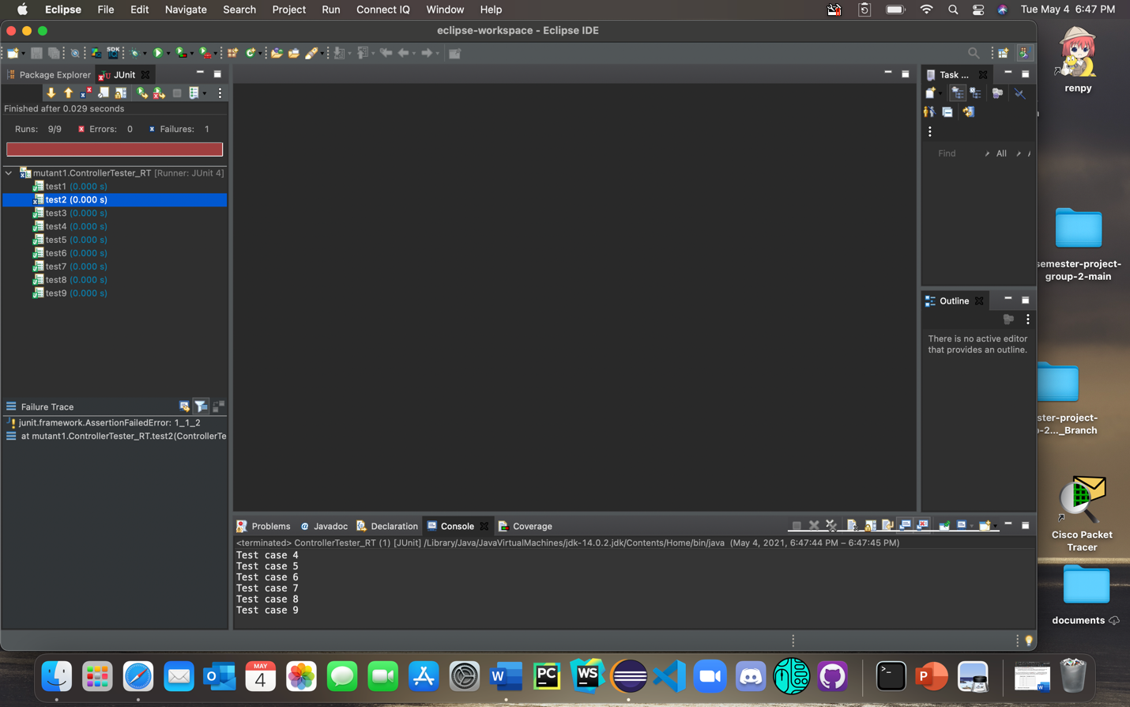

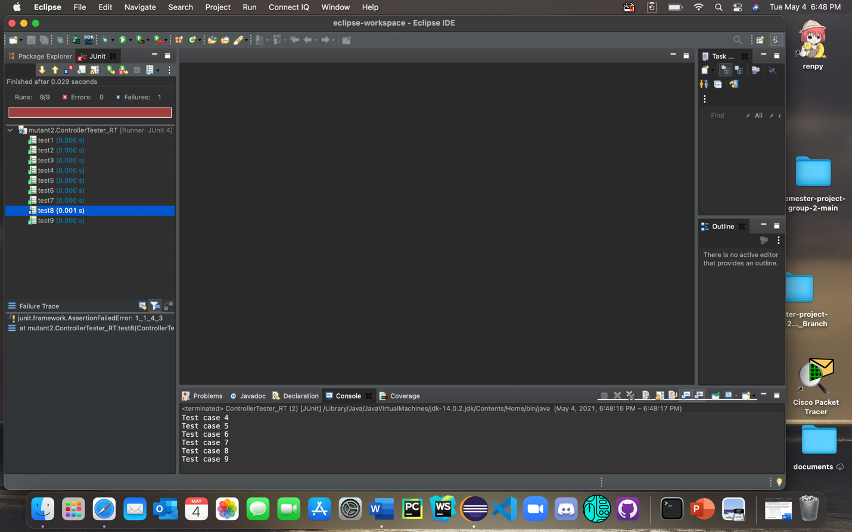

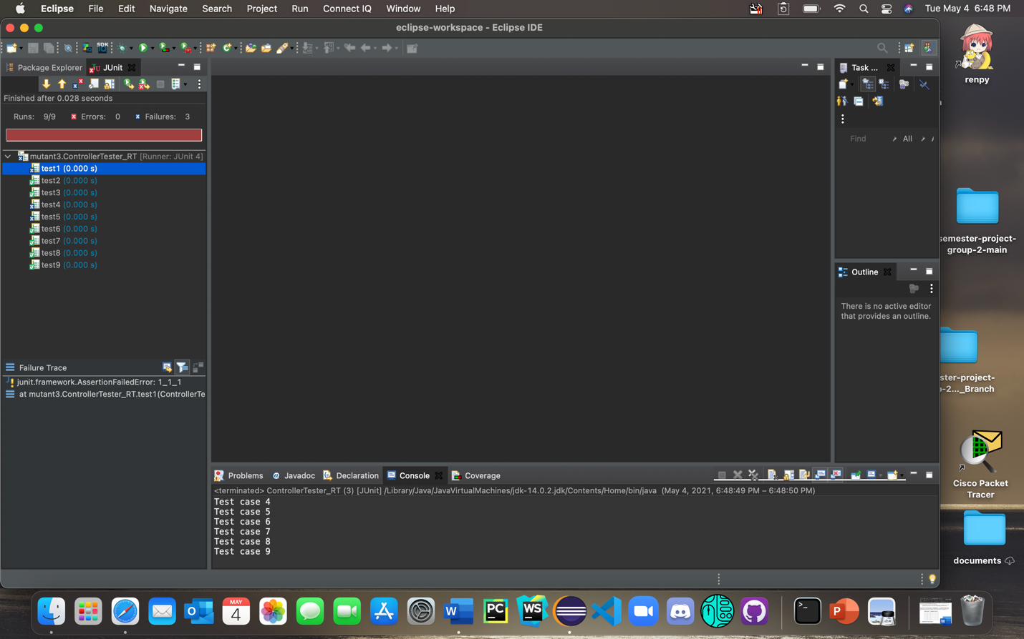

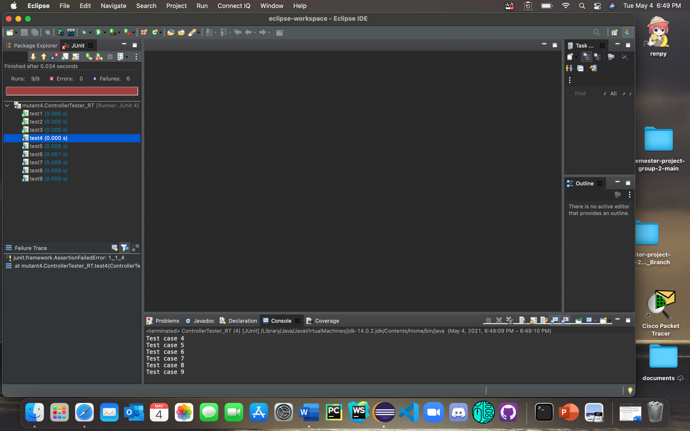

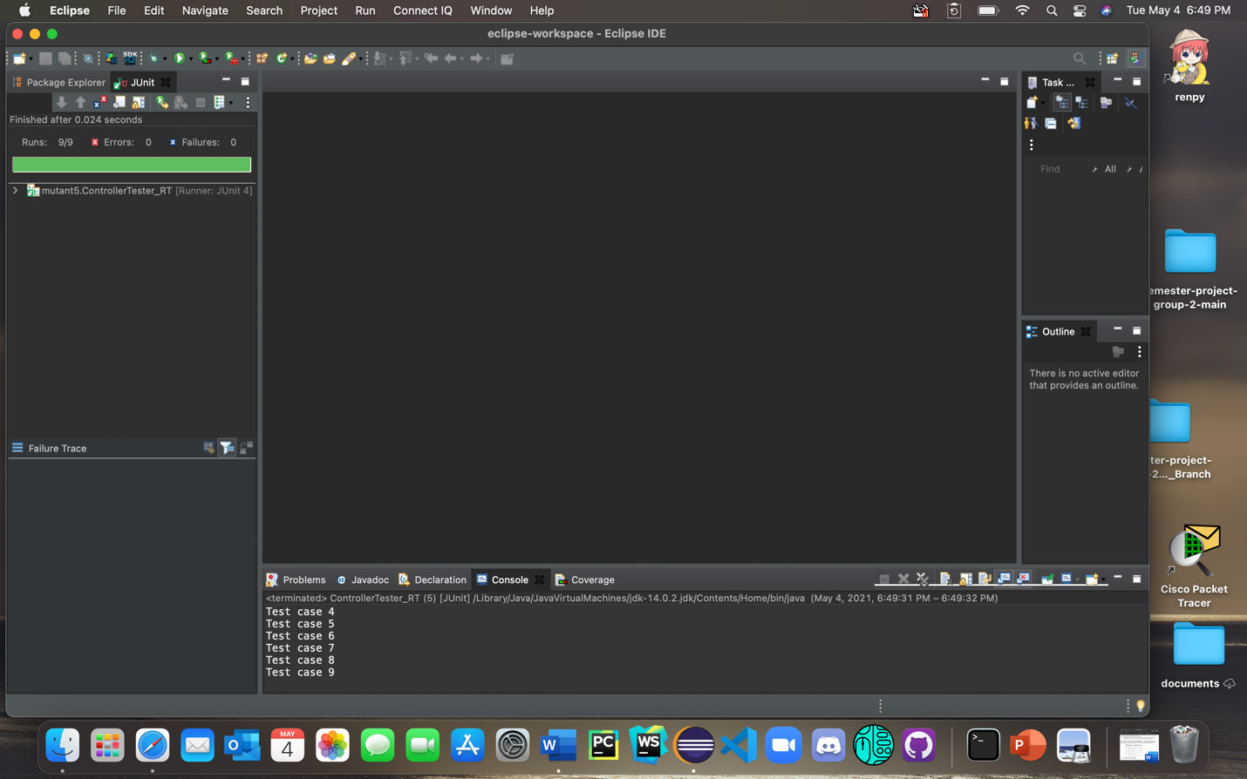

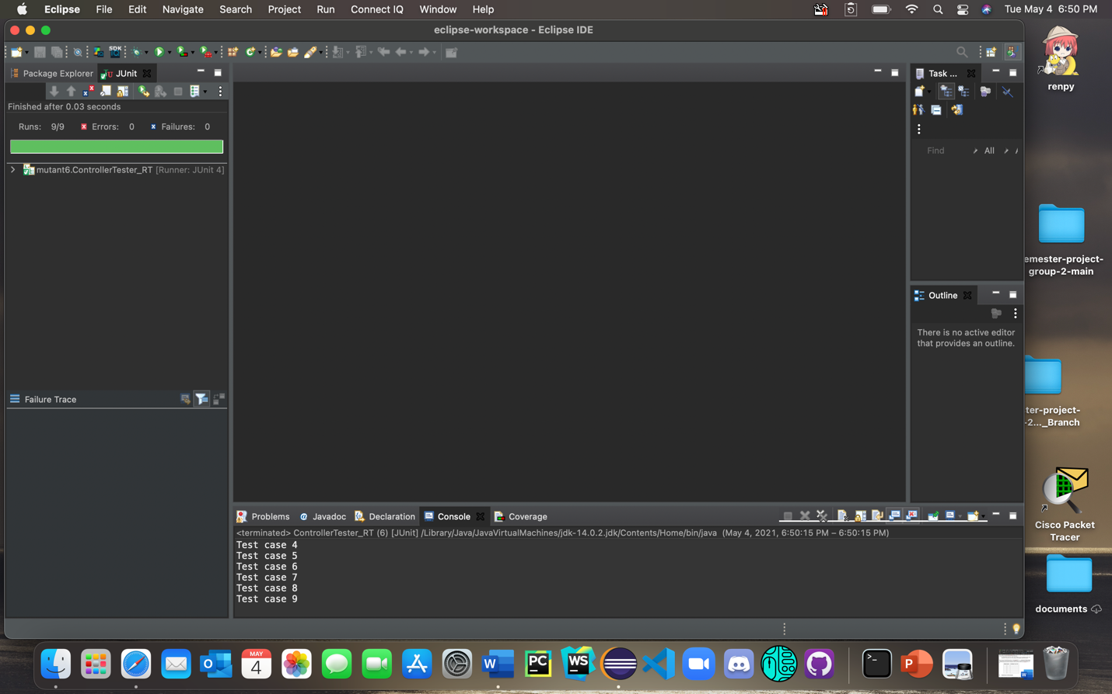

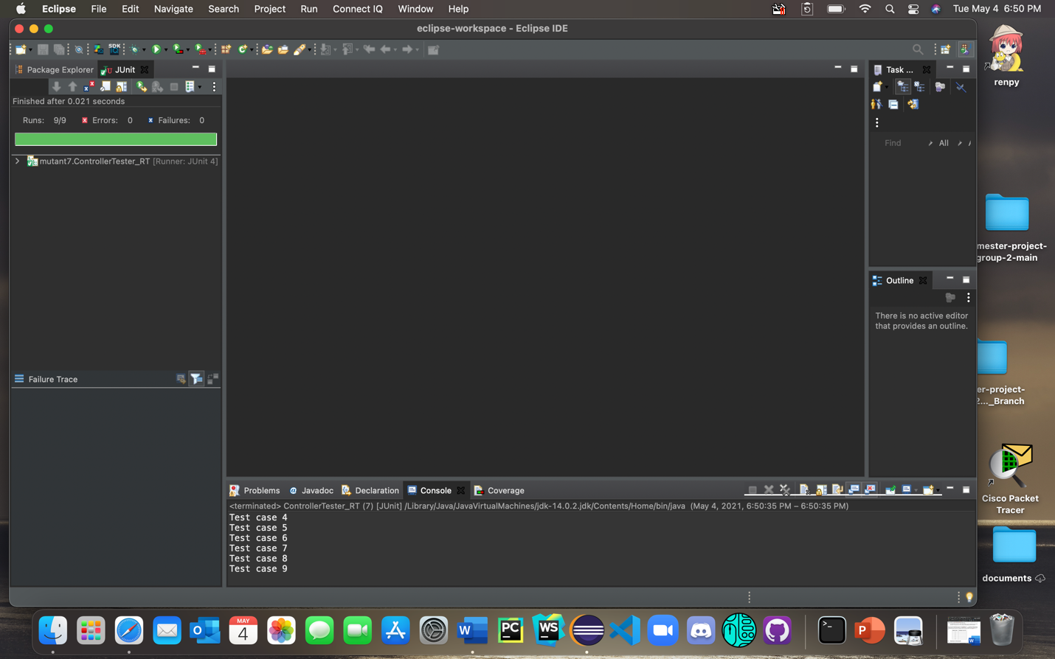

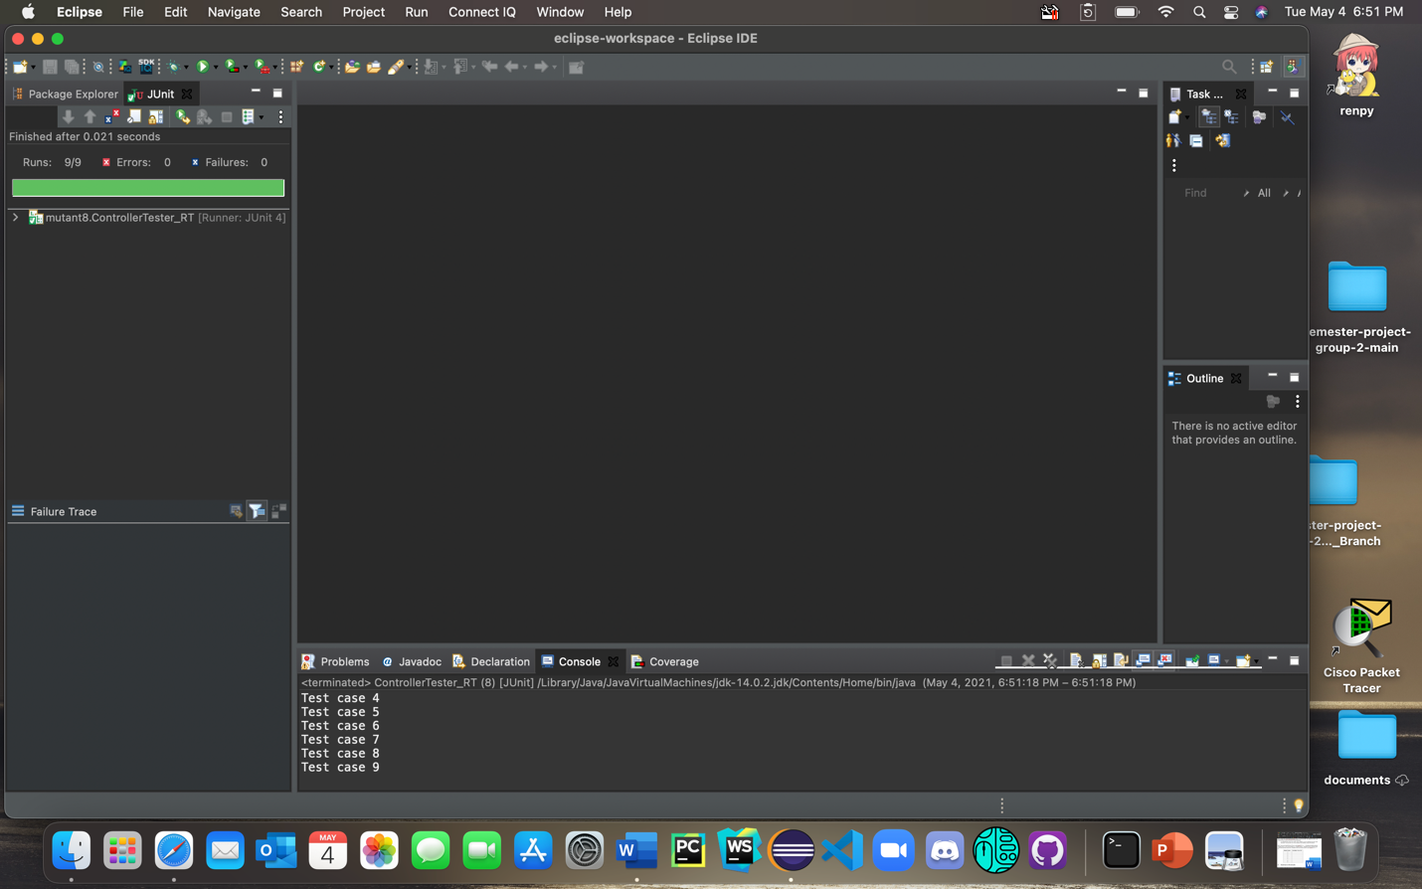

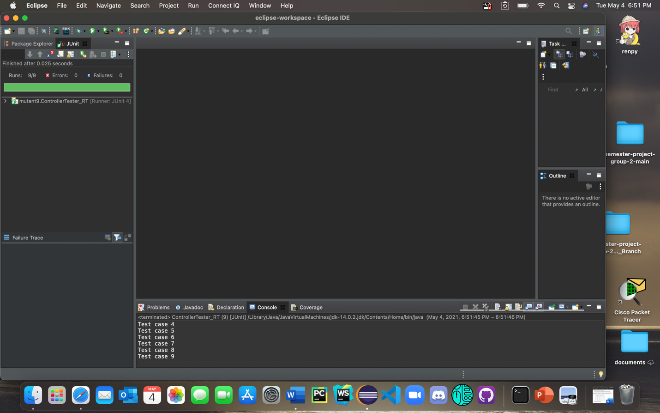

1. **Round-trip tree with sneak paths**

Repeat all the steps in Problem I. The differences are:

Step 2: The two checkboxs may have already been unchecked.

Step 3: Select test generation methods (reachability + invalid paths, Java, JUnit)



Step 4. Generate the test tree: the tree will be different.

Steps 5-7: The generated test code file is named ControllerTester_RTD.java

Report the results of step 7 in the following table and provide a screenshot of the test execution result for each mutantX (X=1, 2, …, 9).

|  |  |
| --- | --- |
| **Mutant Version** | **Test failure: Yes or No?** |
| 1 | Yes |
| 2 | Yes |
| 3 | Yes |
| 4 | Yes |
| 5 | Yes |
| 6 | Yes |
| 7 | No |
| 8 | No |
| 9 | No |

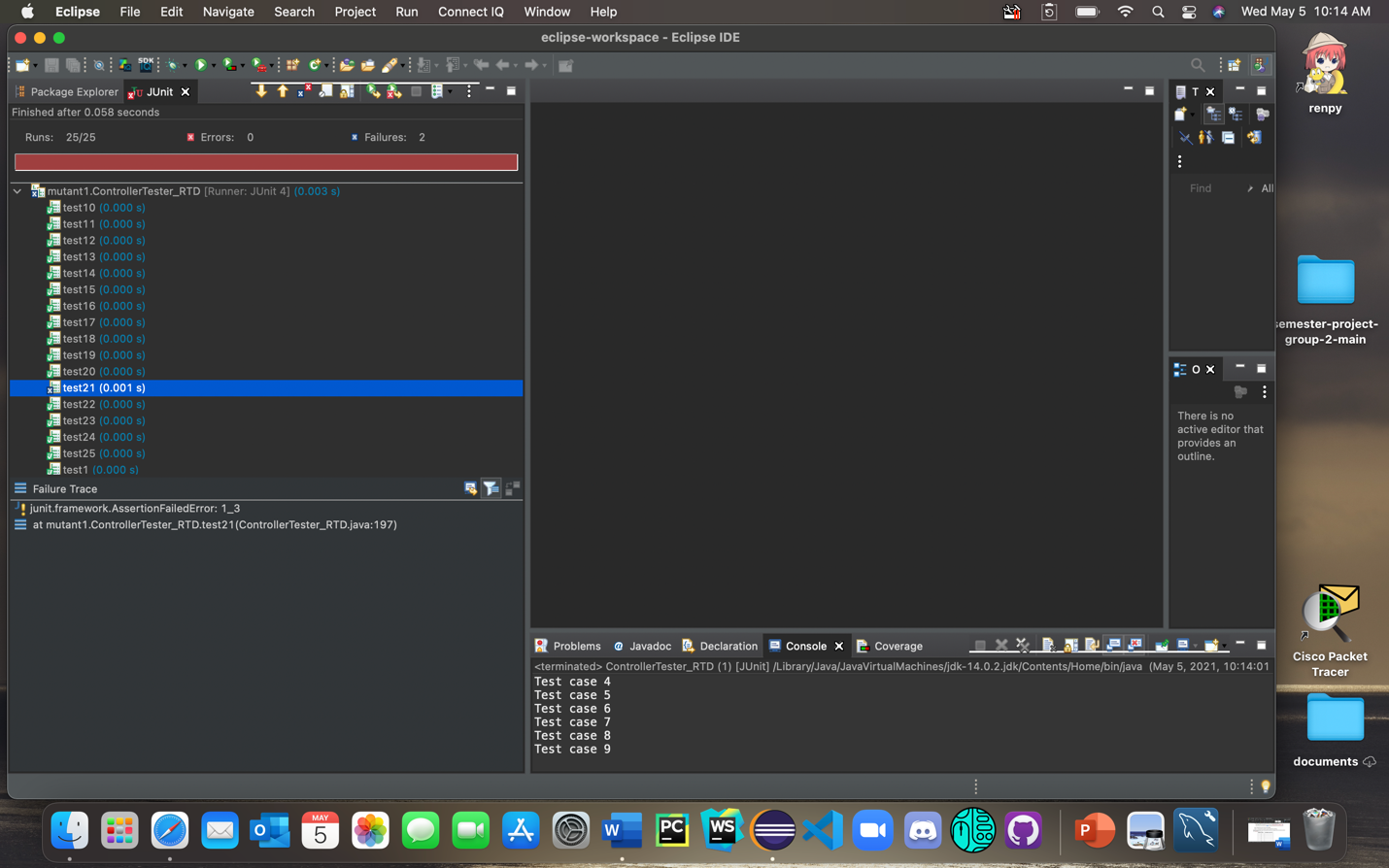

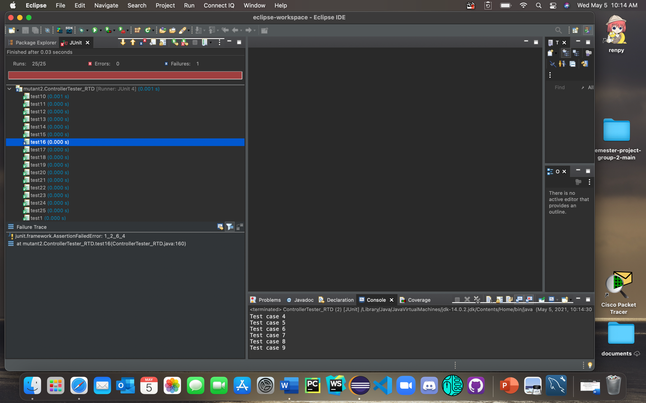

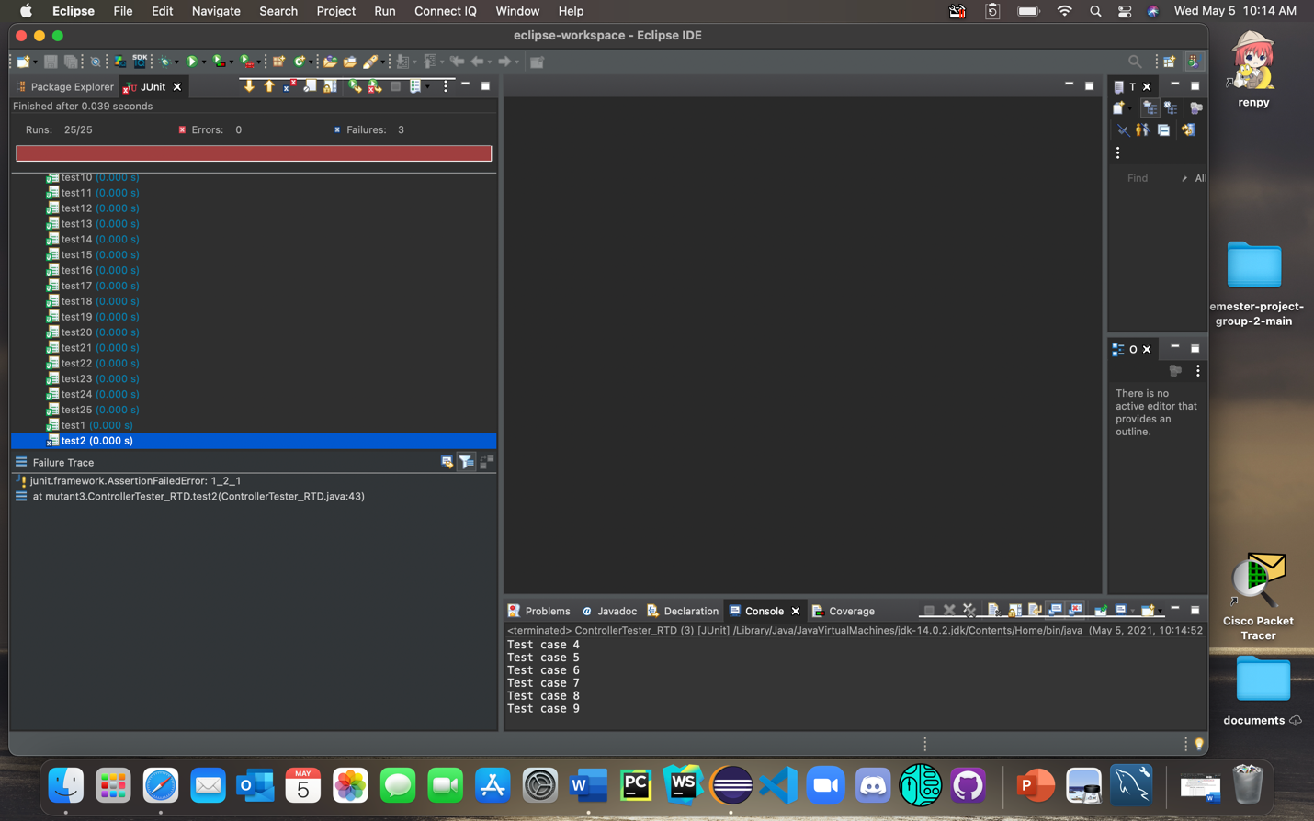

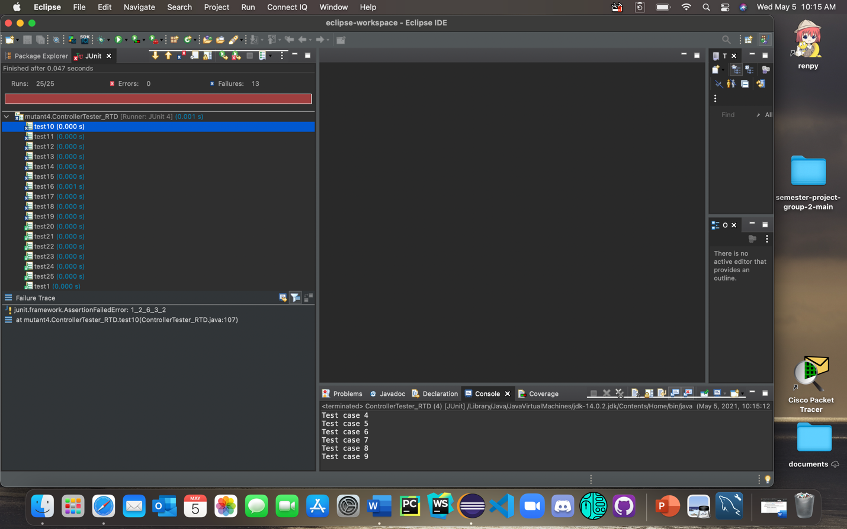

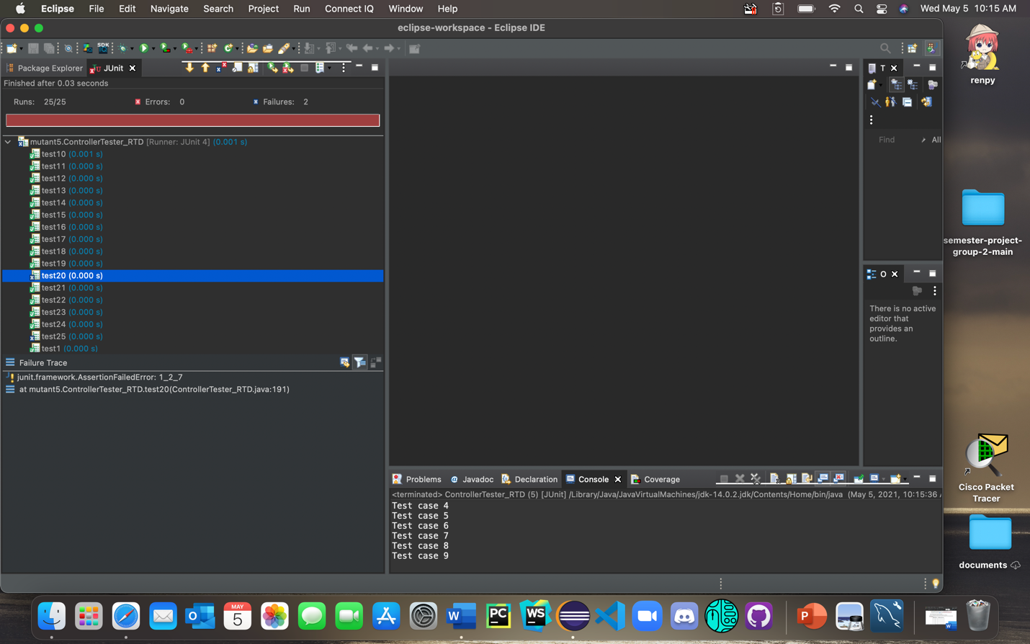

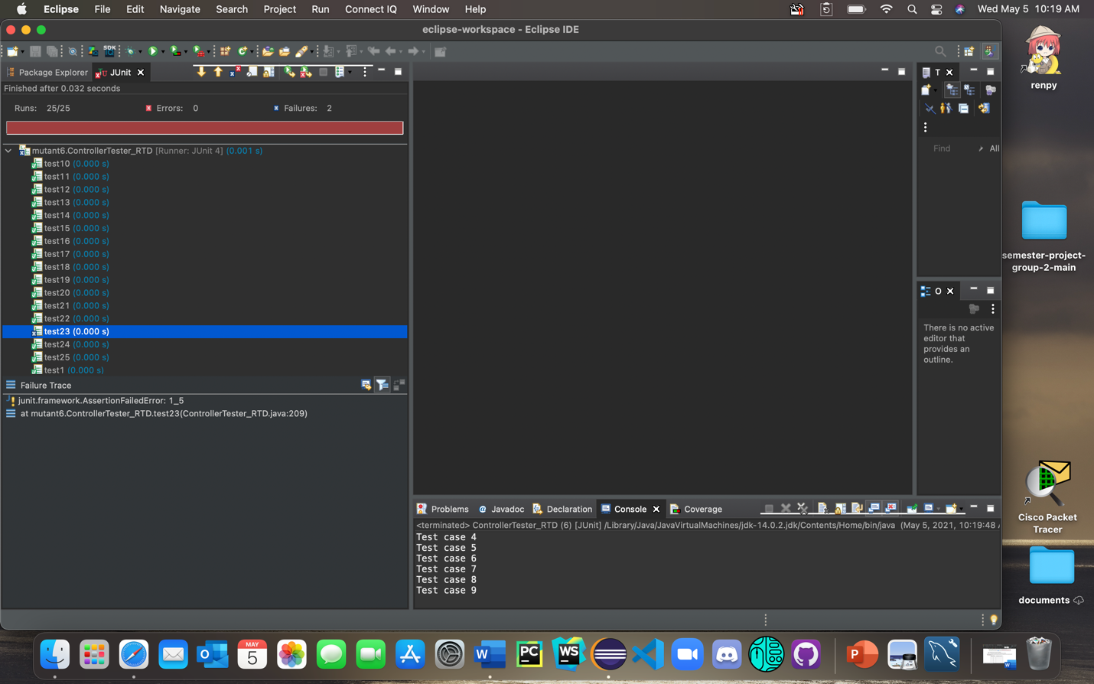

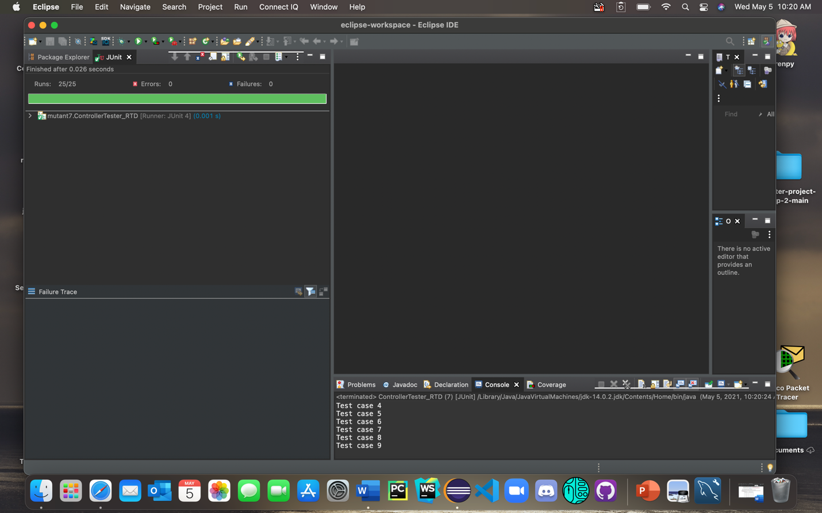

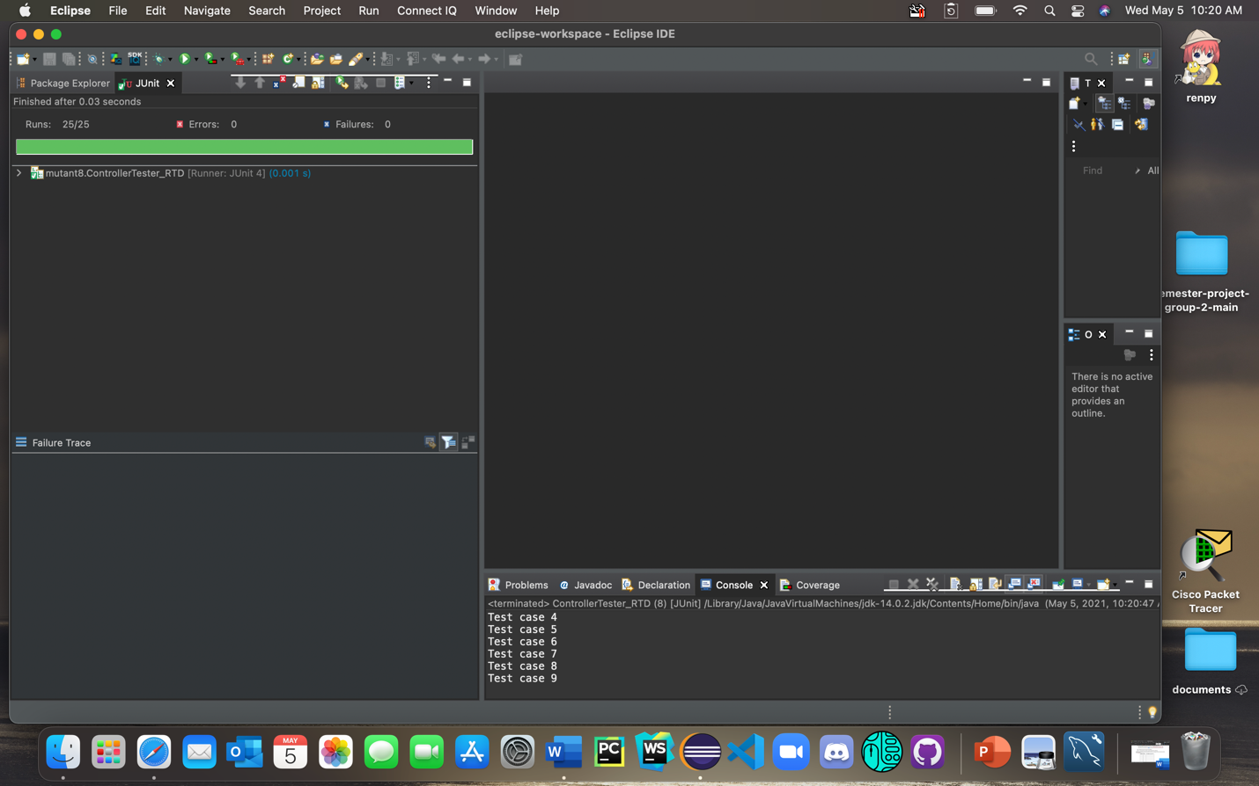

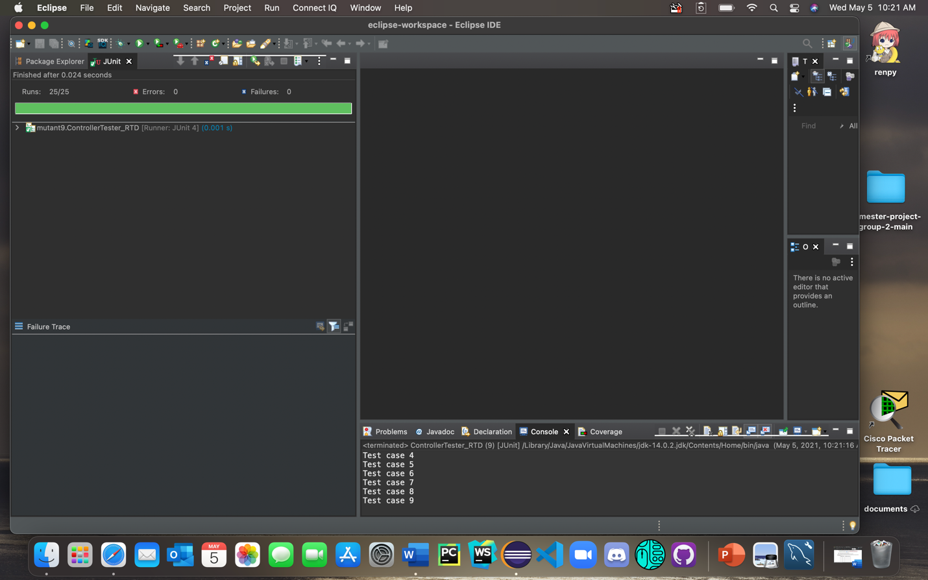

1. **Analysis of the testing methods**
   1. What are the differences between the round-trip tree in Problem I and the round-trip tree with sneak paths in Problem II? **(3 points).**

The round trip-tree in Problem I has less edges traversed as the “sneak paths” were not traveled. The round-trip path in problem II has more edges traversed causing more possibilities to test as the sneak paths were traversed even if it leads to an incomplete finite state machine.

* 1. Compare mutants 7-9 to the correct version and explain why the test suites in Problems I and II cannot kill these mutants. **(6 points).**

Mutant 7 - gets rid of disabling speed control if the control state is equal to cruising (so if the control state does not equal inactive it sets control state to inactive)

Mutant 8 - gets rid of enabling speed control if the control state is inactive (so if the control state does not equal inactive it still sets state control to cruising)

Mutant 9 - gets rid of enabling speed control if the control state is on standby (so if the control state is equal to standby then it sets control state to cruising)

These were not detected by the test suites as the variable speed control was never changed in these mutants

* 1. Discuss how the given finite state model can be enhanced so that the tests in the round-trip tree and the round-trip tree with sneak paths generated from the enhanced state model can reveal the bugs in mutants 7-9 **(5 points).**

The given finite state model can be enhanced so both the round-trip tree and round-trip tree with sneak paths can reveal the bugs in the mutants by enhancing the model where the variable speed control is changed in another node to ensure that the variable could not be overlooked without causing some sort of error. Not too sure but I could see this as a possibility.